Dear Applicant!

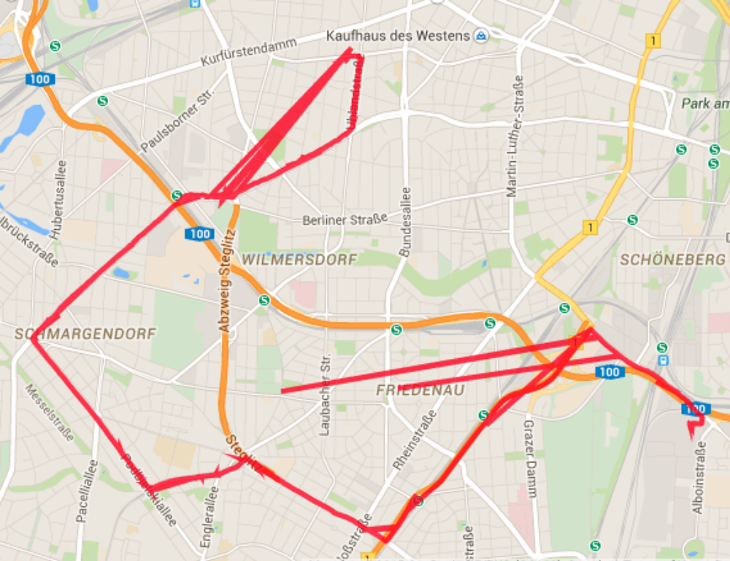
Attached you will find a file with KML map data, describing the route of a vehicle. They are based on sensors and might contain incorrect measurements.
Figure 1: route with incorrect data points
Your task is to write a script in python, that can process the KML datafile, passed to the script as a parameter, read the coordinates and filter out the incorrect data points. The script must also sum up and display the total distance in kilometres, without the incorrect data points.

Also, please write a short documentation
- about the required dependencies,
- how to install the environment and run your script and
- what is the filtering logic your solution is based on.

Please note, that your solution does not need to be perfect. We would like to get a better understanding of your problem solving skills and your way of thinking.
Good luck!

